LAPORAN HASIL UKK 2025

SMKN 1 SIMPANGKATIS
NAMA : FEBRIKA PUTRI DIANA
KELAS : XII PPLG
- Buka folder masuk ke folder xampp,lalu masuk ke folder htdocs,setelah itu buat folder baru dan beri nama sesuai keinginan masing masing
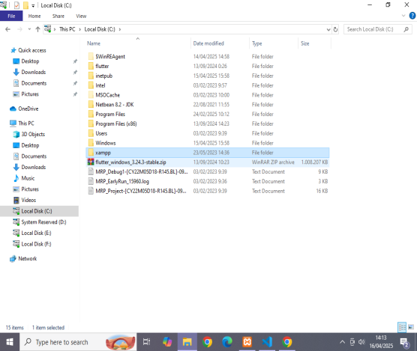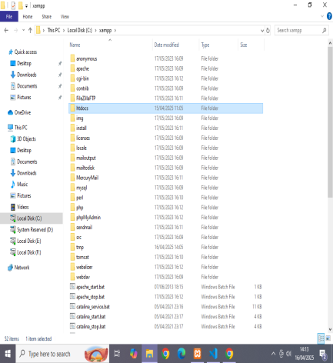
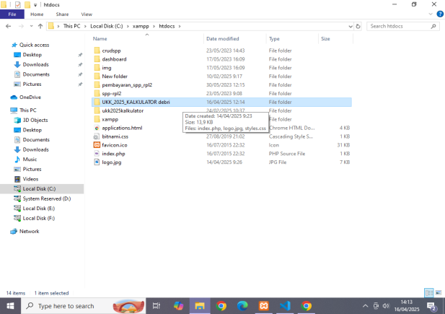

- Lalu jangan lupa hidupkan xampp, setelah itu buka aplikasi visual studio code, setelah itu masukan folder yg sudah kita buat lalu masukan codingan yg ingin kita buat

INDEX.PHP
<!DOCTYPE html>
<html lang="id">
<head>
<meta charset="utf-8">
<meta name="viewport" content="width=device-width, initial-scale=1">
<title>Kalkulator Sederhana | UKK 2025</title>
<link href="https://cdn.jsdelivr.net/npm/bootstrap@5.3.3/dist/css/bootstrap.min.css" rel="stylesheet">
<link rel="stylesheet" href="https://cdnjs.cloudflare.com/ajax/libs/font-awesome/6.7.2/css/all.min.css">
<style type="text/css">
.btn {
width: 100%;
}
.logo {
display: block;
margin: 0 auto;
width: 150px; /* You can adjust the width as per your logo's size */
height: auto;
}
</style>
</head>
<body>
<div class="container mt-5">
<!-- Logo Section -->
<div class="text-center mb-4">
<img src="logo.jpg" alt="Logo Kalkulator" class="logo">
</div>

<h2 class="text-center">Kalkulator</h2>
<div class="row justify-content-center">
<div class="col-md-4">
<form method="POST" class="p-2 border rounded bg-light">
<label class="form-label">Angka Pertama</label>
<input type="text" name="angka1" class="form-control" autocomplete="off" min="0" autofocus required
oninput="this.value = this.value.replace(/[^0-9,\.]/g, '')"
value ="<?php echo isset($_POST['hasil']) ? $_POST['hasil'] : ''?>">
<label class="form-label">Angka Kedua</label>
<input type="text" name="angka2" class="form-control" required oninput="this.value = this.value.replace(/[^0-9,\.]/g, '')">
<div class="d-flex justify-content-center gap-2 mt-2">
<button type="submit" class="btn btn-primary" name="operator" value="+" title="Tambah"><i class="fas fa-plus"></i></button>
<button type="submit" class="btn btn-secondary" name="operator" value="-" title="Kurang"><i class="fas fa-minus"></i></button>
<button type="submit" class="btn btn-success" name="operator" value="*" title="Kali"><i class="fas fa-times"></i></button>
<button type="submit" class="btn btn-info" name="operator" value="/" title="Bagi"><i class="fas fa-divide"></i></button>
</div>
<div class="d-flex justify-content-center gap-2 mt-2">
<button type="reset" name="reset" class="btn btn-warning" value="reset" title="Clear Entry">CE</button>
</div>
</form>

<div class="p-2 border rounded bg-light mt-2">
<h4 class="text-center">
<?php
if (isset($_POST['operator'])) {
// Replace commas with periods for calculations
$angka1 = str_replace([','], ['.'], $_POST['angka1']);
$angka2 = str_replace([','], ['.'], $_POST['angka2']);
$operator = $_POST['operator'];

if (!is_numeric($angka1) || !is_numeric($angka2)) {
echo "<script>alert('Input harus berupa angka')</script>";
} elseif ($operator == '/' && $angka2 == 0) {
echo "<script>alert('Tidak dapat membagi dengan Nol')</script>";
} else {
switch ($operator) {
case '+':
$hasil = $angka1 + $angka2;
break;
case '-':
$hasil = $angka1 - $angka2;
break;
case '*':
$hasil = $angka1 * $angka2;
break;
case '/':
$hasil = $angka1 / $angka2;
break;
default:
echo "Operator tidak valid";
break;
}
// Format the result with comma as decimal separator
echo (fmod($hasil, 1) == 0) ? number_format($hasil, 0, ',', '.') : number_format($hasil, 5, ',', '.');
}
} else {
echo "Hasil : ";
}
?>
</h4>

<div class="row mt-3">
<div class="col-6">
<?php if (isset($hasil) && $hasil !== null) : ?>
<form method="POST">
<input type="hidden" name="hasil" value="<?php echo $hasil ?>">
<button type="submit" class="btn btn-primary" title="Memory Entry">ME</button>
</form>
<?php endif; ?>
</div>
<div class="col-6">
<?php if (isset($hasil) && $hasil !== null) : ?>
<form method="POST">
<button type="submit" name="resethasil" class="btn btn-danger" title="Memory Clear">MC</button>
</form>
<?php endif; ?>
</div>
</div>
</div>
</div>
</div>

<p class="text-center">&copy; UKK RPL 2025 | Febrika Putri Diana | XII PPLG</p>
</div>

<script src="https://cdn.jsdelivr.net/npm/bootstrap@5.3.3/dist/js/bootstrap.bundle.min.js"></script>
</body>
</html>

STYLES CSS
/* Gaya umum */
body {
background-color: #ffffff;
font-family: Arial, sans-serif;
text-align: center;
}

/* Container utama */
.container {
margin-top: 50px;
}

/* Logo */
.logo {
display: block;
margin: 0 auto 10px;
max-width: 120px;
}

/* Judul */
h2 {
font-weight: bold;
margin-bottom: 20px;
}

/* Formulir kalkulator */
form {
background-color: #f8f9fa;
padding: 15px;
border-radius: 8px;
box-shadow: 0px 4px 8px rgba(0, 0, 0, 0.1);
display: inline-block;
width: 100%;
}

/* Label input */
.form-label {
font-weight: bold;
text-align: left;
display: block;
margin-top: 10px;
}

/* Input angka */
.form-control {
width: 100%;
padding: 10px;
margin-bottom: 10px;
border: 1px solid #ced4da;
border-radius: 5px;
font-size: 16px;
text-align: center;
}

/* Tombol operasi */
.d-flex {
display: flex;
justify-content: center;
gap: 10px;
margin-top: 10px;
}

/* Gaya tombol */
.btn {
width: 50px;
height: 50px;
font-size: 18px;
font-weight: bold;
border: none;
border-radius: 5px;
cursor: pointer;
}

/* Warna tombol sesuai fungsi */
.btn-primary { background-color: #007bff; color: white; } /* Tambah */
.btn-secondary { background-color: #6c757d; color: white; } /* Kurang */
.btn-success { background-color: #28a745; color: white; } /* Kali */
.btn-info { background-color: #17a2b8; color: white; } /* Bagi */
.btn-warning { background-color: #ffc107; color: black; } /* Clear */
.btn-danger { background-color: #dc3545; color: white; } /* MC */
.btn-primary:hover, .btn-secondary:hover, .btn-success:hover,
.btn-info:hover, .btn-warning:hover, .btn-danger:hover {
opacity: 0.8;
}

/* Tampilan hasil */
.result-container {
background-color: #bdbebf;
padding: 15px;
border-radius: 8px;
margin-top: 10px;
font-size: 22px;
font-weight: bold;
box-shadow: 0px 4px 8px rgba(0, 0, 0, 0.1);
}

/* Posisi tombol memory */
.row .col-6 {
text-align: center;
margin-top: 10px;
}

- Setelah itu buka chrome dan cari localhost/nama folder kita/
Lalu setelah mencari localhost maka hasilnya akan keluar
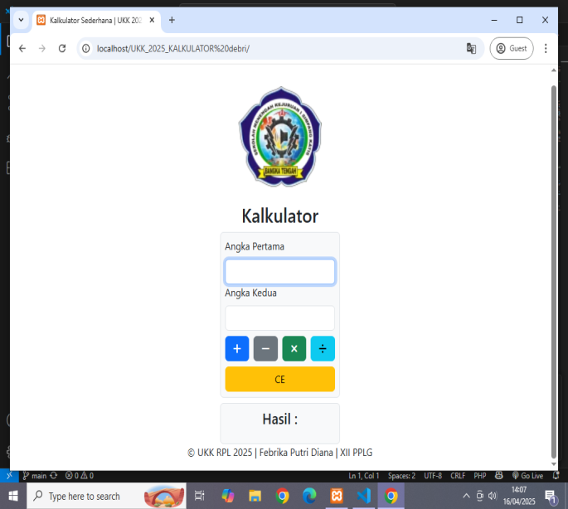

Jika sudah selesai,silahkan coba terlebih dahulu apakah project tersebeut sudah selesai atau masih ada yg error, jika masih terdapat yg error silahkan cari dimana letak salahnya.

